Trouble-ticket-system (java) Project pictures

Total images: 15

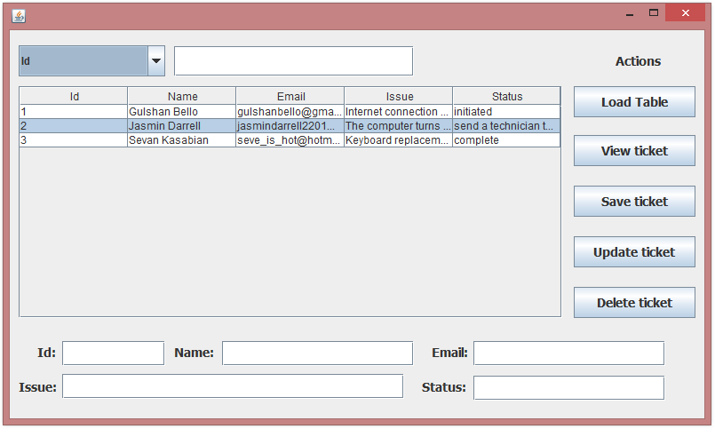

Fig 1: Application GUI

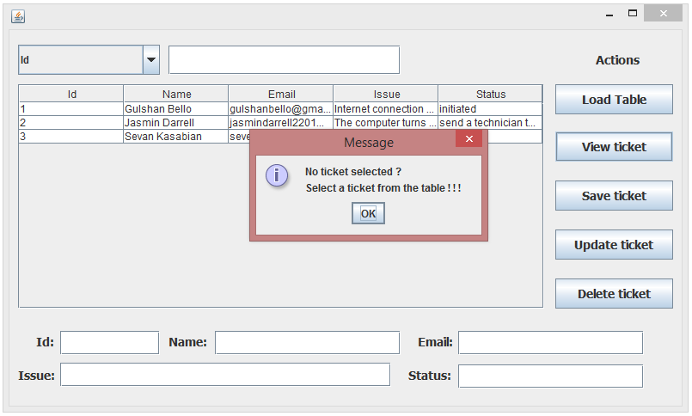

Fig 2: View ticket, select a ticket to view, if not then application shows an error message

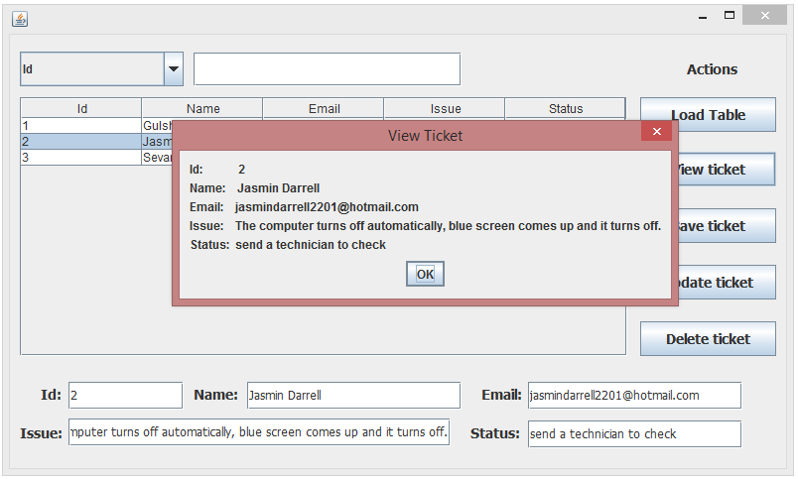

Fig 3: View ticket

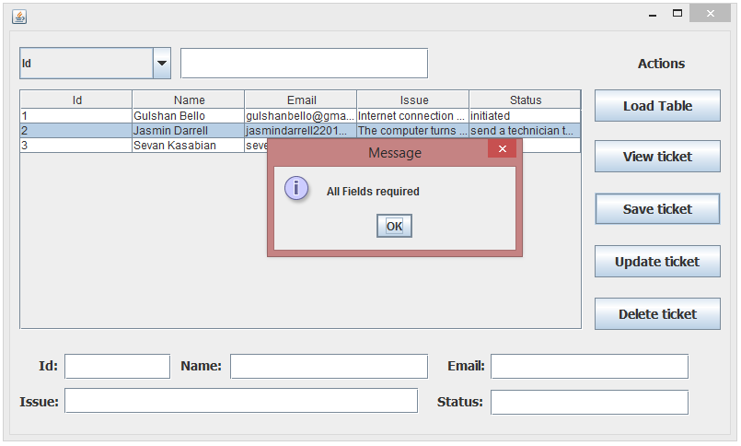

Fig 4: Save ticket, enter valid text in all the fields, if not then application shows an error message

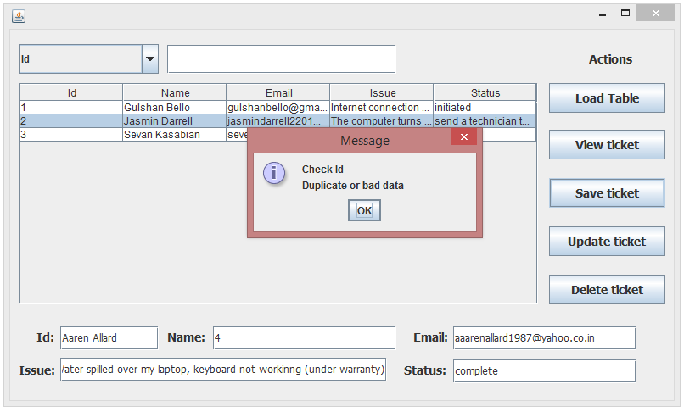

Fig 5: Save ticket, enter valid ID in ID fields, if not then application shows an error message

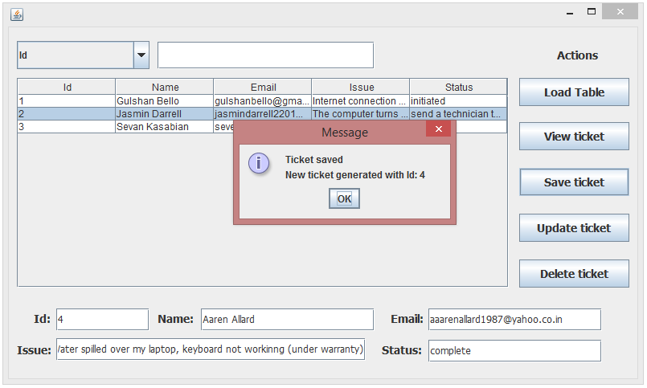

Fig 6: Save ticket

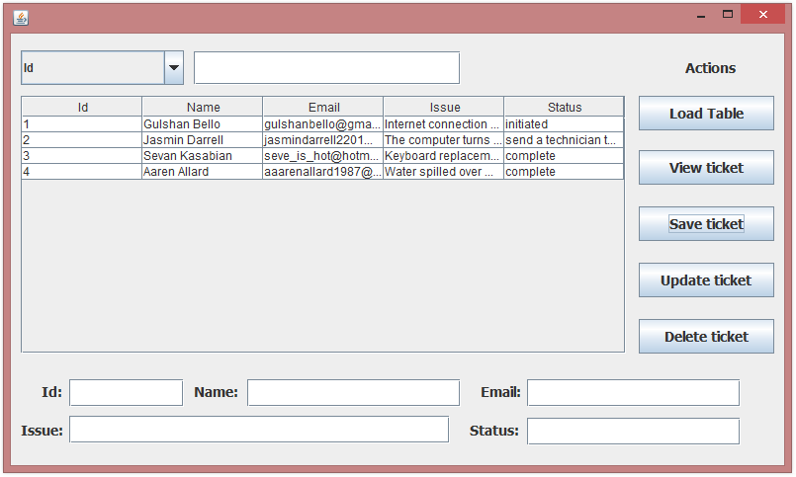

Fig 7: Save ticket, added to the table



Fig 8: Update ticket, select a ticket to update, if not then application shows an error message

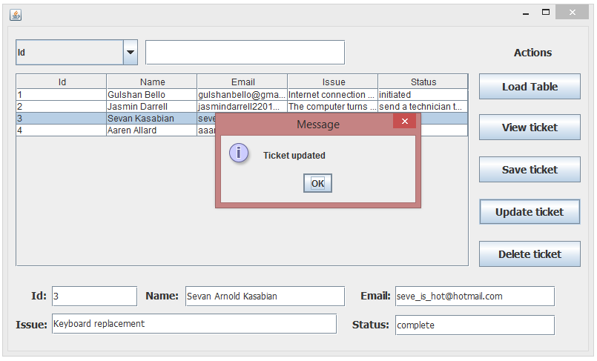

Fig 9: Update ticket (Name - Sevan Kasabian to Sevan Arnold Kasabian)

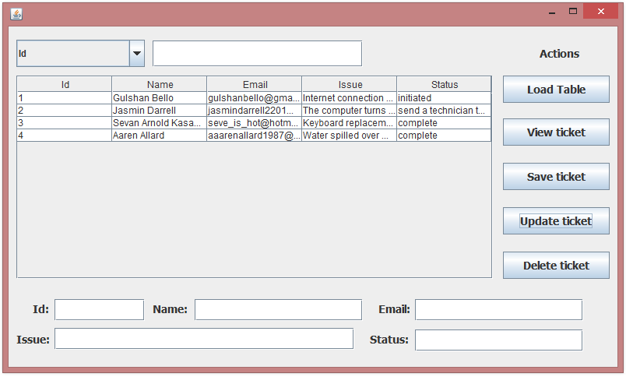

Fig 10: Update ticket, updated in the table



Fig 11: Delete ticket, select a ticket to delete, if not then application shows an error message

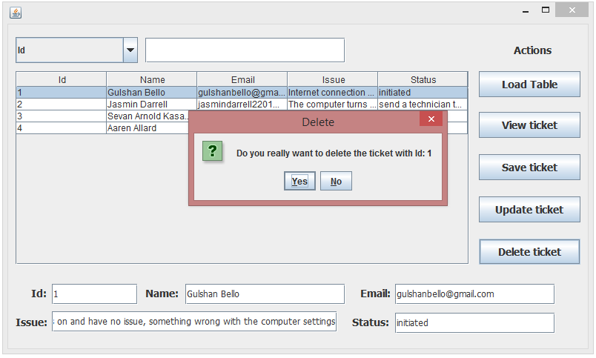

Fig 12: Delete ticket, confirmation

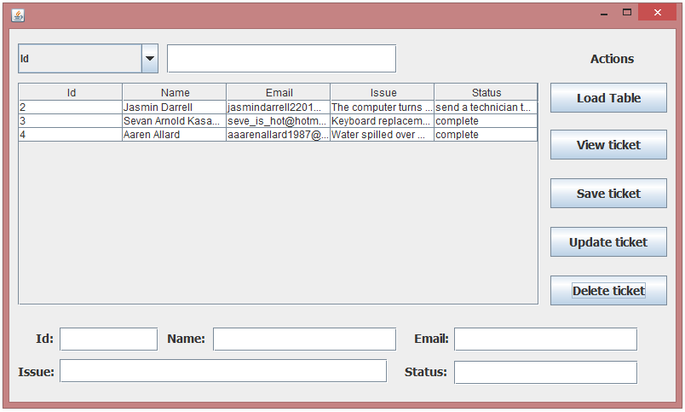

Fig 13: Delete ticket, deleted from the table

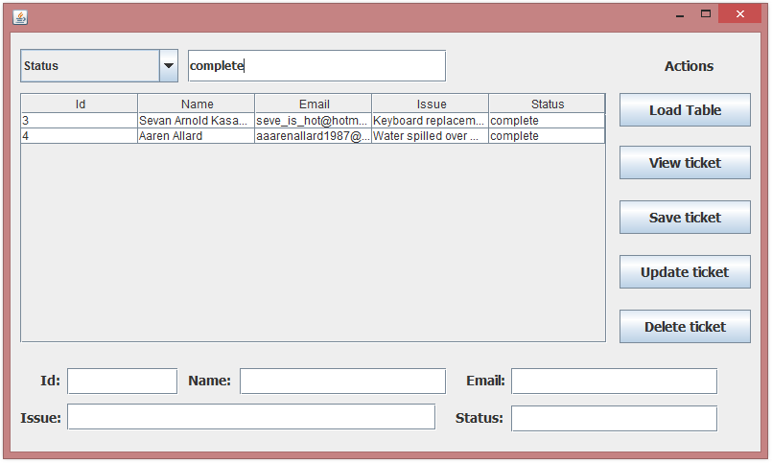

Fig 14: Search a particular from the table (Status == complete)

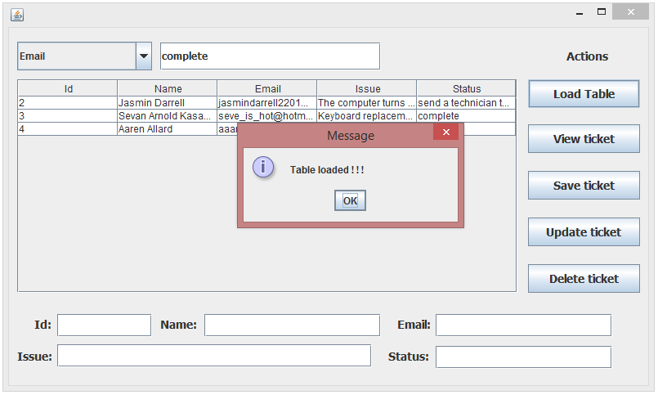

Fig 15: Load complete table again to see all the tickets